**Đáp án bài tập :**

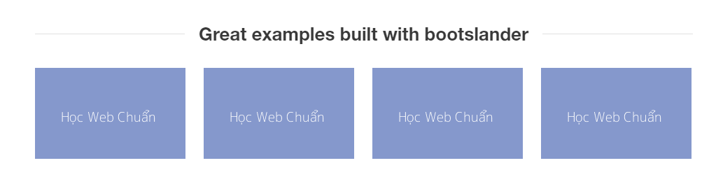

Đáp án :

**Cách 1:**

<!DOCTYPE html>  
<html>  
<head>  
 <title></title>  
 *<!-- external style -->* <style type="text/css">  
 .study {  
 */*float: left cố định phần tử về bên trái*/* float: left;  
 */*tạo border với độ rộng trên phải dưới trái là 1px , solid là nét liền, màu đen*/* border: 1px solid black;  
 margin: 10px 20px;  
 */*màu nền của phần tử*/* background-color: blue;  
 */*khoảng cách giữa border và nội dung(content) bên trong*/* padding: 20px;  
 }  
 </style>  
</head>  
<body>  
 <div class="container">  
 <div class="study">Hoc web</div>  
 <div class="study">Hoc web</div>  
 <div class="study">Hoc web</div>  
 <div class="study">Hoc web</div>  
 </div>  
</body>  
</html>

**Cách 2 :**

<!DOCTYPE html>  
<html>  
<head>  
 <title></title>  
 *<!-- external style -->* <style type="text/css">  
 .study {  
 */*nhiều phần tử inline sẽ có thể hiện thị trên cùng 1 hàng được, thêm để thay đổi thuộc tính mặc định block của thẻ div thành inline*/***display: inline;** */*tạo border với độ rộng trên phải dưới trái là 1px , solid là nét liền, màu đen*/* border: 1px solid black;  
 margin: 10px 20px;  
 */*màu nền của phần tử*/* background-color: blue;  
 */*khoảng cách giữa border và nội dung(content) bên trong*/* padding: 20px;  
 }  
 </style>  
</head>  
<body>  
 <div class="container">  
 <div class="study">Hoc web</div>  
 <div class="study">Hoc web</div>  
 <div class="study">Hoc web</div>  
 <div class="study">Hoc web</div>  
 </div>  
</body>  
</html>

**Bài 1: Có css (external)**

Vận dụng kiến thức bài trên để làm.



Đáp án :

<!DOCTYPE html>  
<html lang="en">  
<head>  
 <meta charset="UTF-8">  
 <title>Title</title>  
 <style type="text/css">  
 body {  
 background-color: #f2f3f5;  
 color: #999;  
 font-family: Helvetica, sans-serif;  
 font-size: 16px;  
 line-height: 1.8;  
 }  
  
 .service .lead-text {  
 font-size: 18px;  
 margin-bottom: 57px;  
 text-align: center;  
 }  
  
 .service h2 {  
 color: #1f1f1f;  
 font-size: 40px;  
 margin-bottom: 17px;  
 text-align: center;  
 }  
  
 .half-above {  
 height: 50%;  
 background-color: #91e0e6;  
 */*padding: 2px;*/* }  
  
 .half-under {  
 height: 50%;  
 background-color: white;  
 padding: 10px;  
 }  
  
 .container-flex {  
 height: 400px;display: flex;  
 flex-direction: row;  
 justify-content: space-between;  
 }  
  
 .child-flex {  
 background: blue;height: 100%;  
 width: 30%;  
 vertical-align: middle;  
 display: flex;  
 flex-direction: column;  
 border: 1px solid black;  
 }  
  
 .middle {  
 position: relative;  
 top: 50%;  
 text-align: center;  
 color: white;  
 font-size: larger;  
 }  
 </style>  
</head>  
<body>  
<div class="service">  
 <h2>Our Service</h2>  
 <p class="lead-text">Our Service lorem ipsum dolor sit amet, consectetur adipiscing elit. Nam sed ipsum erat. Donec  
 feugiat ipsum ac risus auctor dignissim. Phasellus ante dolor, molestie vitae malesuada id, posuere non est.</p>  
</div>  
<div class="container-flex">  
 <div class="child-flex">  
 <div class="half-above">  
 <div class="middle">  
 Noi dung 1  
 </div>  
 </div>  
 <div class="half-under">  
 <h3>Smart Swatch Editions</h3>  
 <p class="info">Augue et dapibus. Nullam venenatis ornare arcu at placerat. Ut eget metus velit. Nam  
 porttitor, arcu eu efficitur ornare, turpis nulla vehicula mauris.</p>  
 </div>  
 </div>  
 <div class="child-flex">  
 <div class="half-above">  
 <div class="middle">  
 Noi dung 1  
 </div>  
 </div>  
 <div class="half-under">  
 <h3>Smart Swatch Editions</h3>  
 <p class="info">Augue et dapibus. Nullam venenatis ornare arcu at placerat. Ut eget metus velit. Nam  
 porttitor, arcu eu efficitur ornare, turpis nulla vehicula mauris.</p>  
 </div>  
 </div>  
 <div class="child-flex">  
 <div class="half-above">  
 <div class="middle">  
 Noi dung 1  
 </div>  
 </div>  
 <div class="half-under">  
 <h3>Smart Swatch Editions</h3>  
 <p class="info">Augue et dapibus. Nullam venenatis ornare arcu at placerat. Ut eget metus velit. Nam  
 porttitor, arcu eu efficitur ornare, turpis nulla vehicula mauris.</p>  
 </div>  
 </div>  
</div>  
</body>  
</html>

Bài 2:

Vẽ các hình khối giao diện như sau: có border, chữ , màu nền.

Dùng style css internal

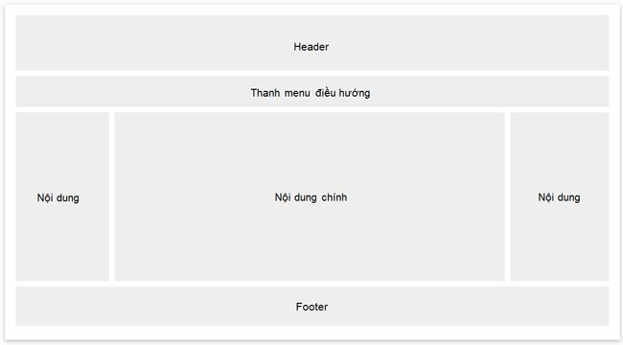

Đáp án :

<!DOCTYPE html>  
<html lang="en">  
<head>  
 <meta charset="UTF-8">  
 <title>Title</title>  
 <style type="text/css">  
 .main {  
 border: 1px solid black;  
 padding: 20px;  
 height: 400px  
 }  
 .middle {  
 position: relative;  
 top: 50%  
 }  
 </style>  
</head>  
<body>  
<div class="main">  
 <div style="background: red; margin-bottom: 10px;height: 20%;text-align: center;vertical-align: middle;">  
 <div class="middle">  
 Header  
 </div>  
 </div>  
 <div style="background: blue; margin-bottom: 10px;text-align: center;height: 20%;vertical-align: middle;">  
 <div class="middle">  
 Thanh menu dieu huong  
 </div>  
 </div>  
 <div style="height: 40%;display: flex; flex-direction: row">  
 <div style="background: blue; margin-bottom: 10px; margin-right:2%;text-align: center;height:100%;width: 23%;vertical-align: middle;display: flex;flex-direction: column">  
 <div style="background-color: green;height: 50%;">  
 Noi dung 1  
 </div>  
 <div style="background-color: white;height: 50%;">  
 Noi dung 2  
 </div></div>  
 <div style="background: blue; margin-bottom: 10px;margin-right:2%;text-align: center;height:100%;width: 50%;vertical-align: middle;">  
 <div class="middle">  
 Noi dung 2  
 </div>  
 </div>  
 <div style="background: blue; margin-bottom: 10px;text-align: center;width: 23%;height:100%;vertical-align: middle;">  
 <div class="middle">  
 Noi dung 3  
 </div>  
 </div>  
 </div>  
 <div style="background: blue; margin-top: 10px;text-align: center;height: 13%;vertical-align: middle;">  
 <div class="middle">  
 Footer  
 </div>  
 </div>  
</div>  
</body>  
</html>